British Photodermatology Group Position Statement:
Ultraviolet (UV) emissions and Compact Fluorescent Lights

Background
Legislation in Europe and United States has led to the phasing out of incandescent light bulbs. Similar legislation has been passed in several other countries. The principal driver is to improve lighting efficiency in order to reduce carbon dioxide emissions.
Incandescent (tungsten) bulbs have been replaced largely by compact fluorescent lamps (CFLs) and light emitting diodes (LEDs). CFLs with a bare tube are generally termed “single envelope” CFLs and those in which the tube is enclosed in a glass or polycarbonate cover are designated “double envelope” bulbs.
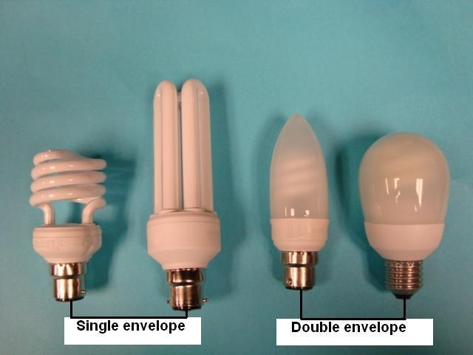
The UV spectrum is usually divided according to wavelength into UVA (315-400nm) which is closest to visible light, UVB (280-315nm) and UVC (100-280nm). The UV emission from each light source is very different. Although the traditional tungsten lamp emits measureable amounts of UVA, the UVB levels are extremely low and the heat from this lamp limits exposure at close distance. In contrast, the CFL emissions are widely variable, depending on the individual lamp. The single envelope CFL in particular has been shown to emit significant quantities of UVB in some cases and also measureable amounts of UVC. Light emitting diodes (LEDs) have virtually no UV emission.
There are many skin conditions caused or exacerbated by exposure to UV radiation. These include polymorphic light eruption, chronic actinic dermatitis, solar urticaria, xeroderma pigmentosum and lupus erythematosus. Investigations carried out on photosensitive patients have shown that exposure to single envelope CFL can induce an erythematous reaction in photosensitive individuals. The number of reactions was much reduced when double envelope CFLs were used and, for all UV-sensitive patients, responses to exposure from the LED were negative. Currently, there is no scheme in place to indicate to photosensitive patients or to healthcare professionals which lamps are safe to use. Some patients, including those with lupus and some other connective tissue diseases, describe a variety of symptoms both in the skin and systemically. Investigations carried out in patients with light-sensitive skin disorders found that CFLs, when situated in close proximity to the skin, can induce erythema that is more pronounced and persistent than in healthy individuals. Energy efficient halogen lamps can also induce skin erythema in some light-sensitive individuals. LEDs provide a safer alternative without the UV skin risk but it should be noted that they do exhibit a strong blue/violet emission.
The exposure to UV radiation is also recognised as a risk factor for skin cancer. However, any change in personal risk as a result of exposure to UV from CFLs is considered to be very small and much less than the risk from UV exposure outdoors.
- Occupational exposure to UV radiation within the EU is subject to the Artificial Optical Radiation Directive which specifies exposure limit values for workers and also obliges the employer to consider any effects concerning safety of staff belonging to particularly sensitive groups. It should also be noted that the Health Protection Agency has issued precautionary advice to the public to maintain a distance of at least 30cm from a single envelope CFL.
Recommendations
- CFLs present a low level of risk to the skin of individuals of normal sensitivity but are potentially harmful to photosensitive patients.
- Some single envelope CFLs emit detectable levels of UVA, UVB and UVC that may provoke a skin reaction in photosensitive individuals.
- Double envelope CFLs emit lower levels of UVB and UVC and are therefore a safer alternative for UV-sensitive individuals.
- LEDs have minimal UV emissions and are therefore a safer alternative to CFLs for UV-sensitive individuals.
- We advocate the introduction of a lamp classification scheme suitable for UV-sensitive individuals.
References
1 Eadie E, Ferguson J, Moseley H. A preliminary investigation into the effect of exposure of photosensitive individuals to light from compact fluorescent lamps. British Journal of Dermatology 2009; 160: 659-64.
2 Fenton L, Ferguson J, Moseley H. Analysis of energy saving lamps for use by photosensitive individuals. Photochemistry and Photobiological Sciences 2012; 11.
3 Moseley H, Ferguson J. The risk to normal and photosensitive individuals from exposure to light from compact fluorescent lamps. Photodermatology, Photoimmunology & Photomedicine 2011; 27: 131-7.
4 Khazova M, O’Hagan JB. Optical radiation emissions from compact fluorescent lamps. Radiation Protection Dosimetry 2008; 131: 521-5.
5 Nuzum-Klein A, Sontheimer R. Ultraviolet light output of compact fluorescent lamps: comparison to conventional incandescent and halogen residential lighting sources. Lupus 2009; 18: 556-60.
6 Sayre R, Dowdy J, Poh-Fitzpatrick M. Dermatolgical risk of indoor ultraviolet exposure from contemporary lighting sources. Photochemistry and Photobiology 2004; 80: 47-51.
7 Scientific Committee on Emerging and Newly Identified Health Risks. European Commission, Directorate-General for Health & Consumers. Health effects of artificial light. Opinion adopted on 19th March 2012. Available at: http://ec.europa.eu/health/scientific_committees/emerging/opinions/index_en.htm
- Fenton L, Ferguson J, Ibbbotson S, Mosley H. Energy-saving lamps and their impact on photosensitive and normal individuals. British Journal of Dermatology 2013; 169: 910-915
- Fenton L, Moseley H. UV emissions from low energy artificial light sources. Photodermatology, Photoimmunology & Photomedicine 2014; 30: 153-159
- Fenton L, Dawe R, Ibbotson S, Ferguson J, Silburn S, Moseley H. Impact assessment of energy-efficient lighting in patients with lupus erythematosus: a pilot study. British Journal of Dermatology 2014; 170: 694-698

PRODUCED JANUARY 2013
UPDATED JULY 2016

REVIEW DATE JULY 2019

